3G150S-How to setup the router in WISP Mode？
Product line:3G Question category: Internet settings
Q: When do we choose the WISP mode?
A: WISP is one of the connection modes, which allows a wireless network to be expanded without an Ethernet cable between the devices.
The topology is as follows:

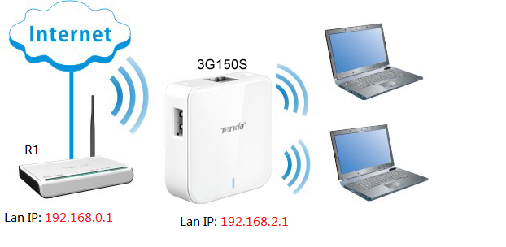
Note:
LAN IP of 3G150S should be in the different subnet of the root router (R1), as the topology shows.

Steps:
1. Use a cable connect a computer to the Lan/Wan port or connect to the wireless name like Tenda_xxxxxx on the laptop (default password:12345678), then open a web browser, put 192.168.2.1 in the address bar.
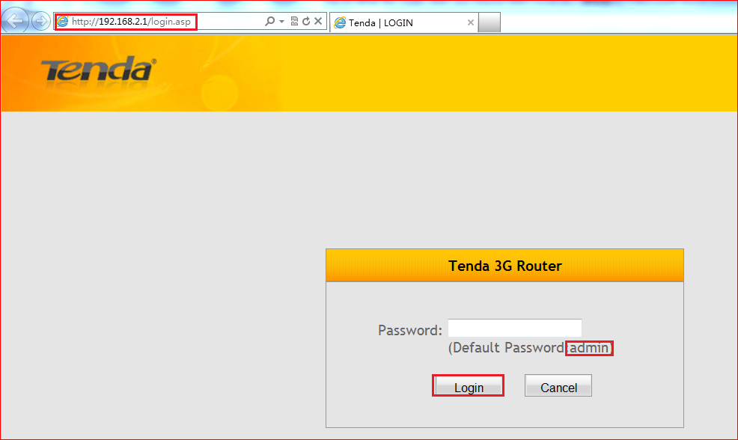
Type admin and hit apply, then check WISP Mode, hit Quick Setup
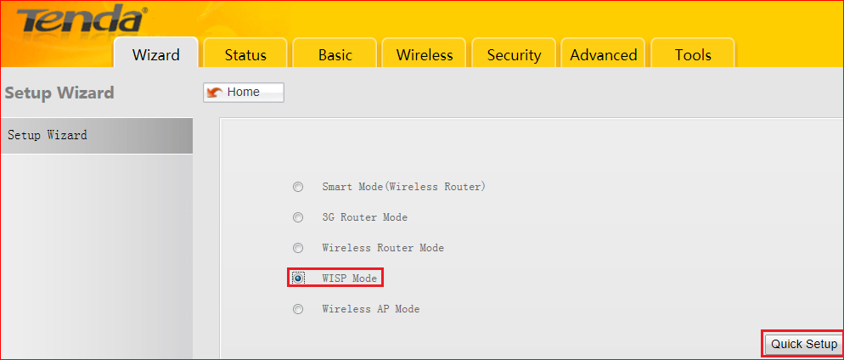
2. First click on Scan, find the SSID (the wireless network which you want to expand) and check it. Please pay attention to the red words on the following picture.
Note: Channel, Security, Cipher Type and Security key should be as some as the main router R1.

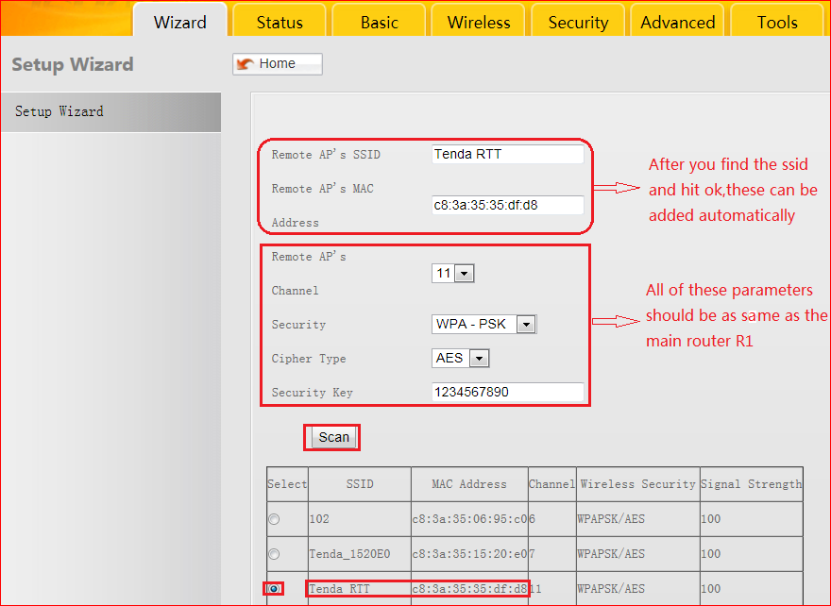
3. Click on Next to enter the following page, set a wireless name in the SSID and set a wireless password in Security key, hit Next.
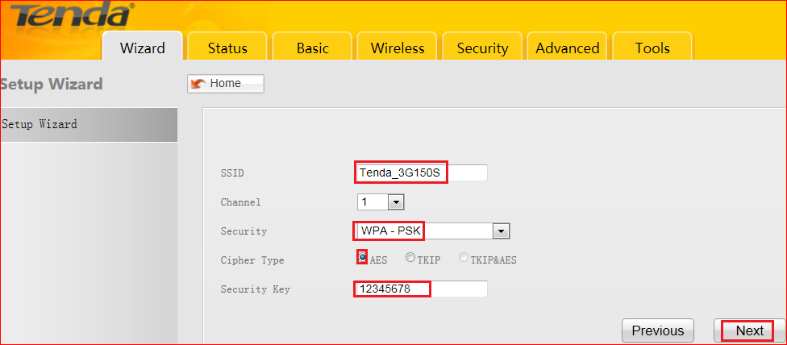
Choose DHCP, click Clone Your PC’s MAC →Next →Save

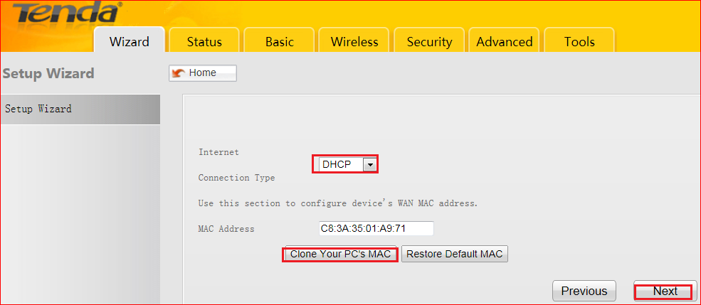
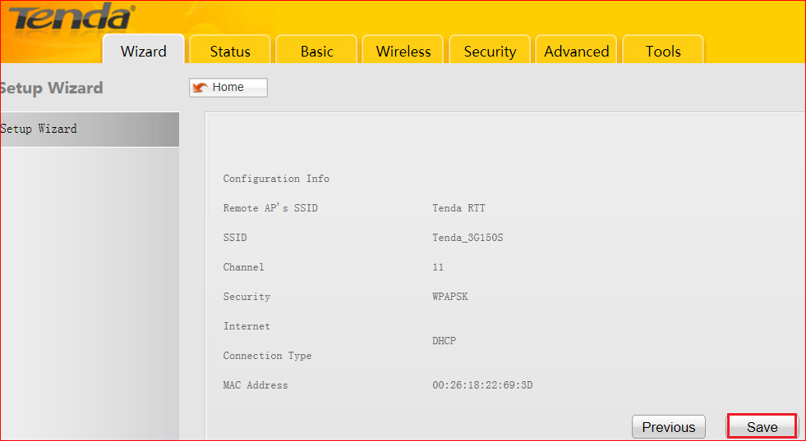
4.It will reboot when hit on save, go to Status → WAN Status when the reboot is done.
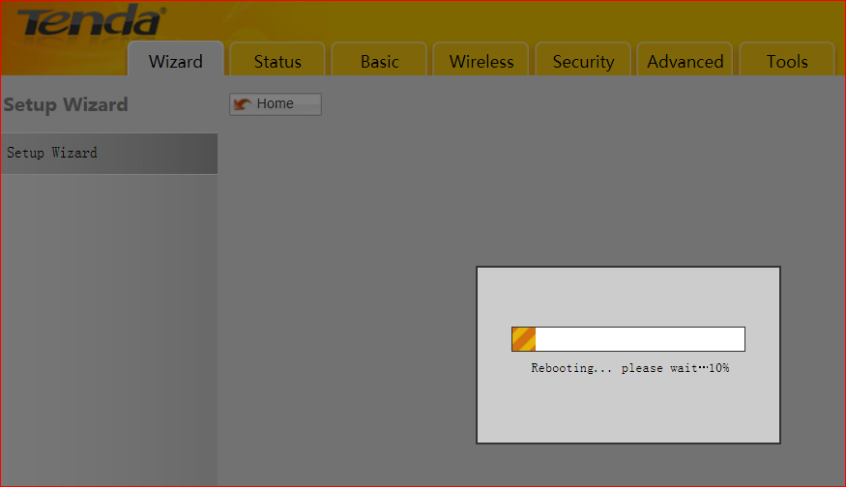

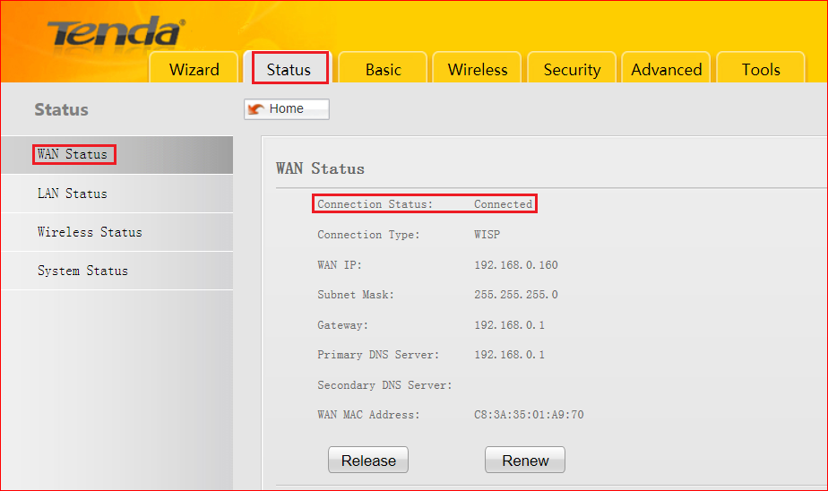

- If connection status says connected, the wisp mode has been configured successfully.

- If it says disconnected, go to Basic → LAN Settings, change the IP address as the following picture shows, at last hit Save

